C. LISTENING SKILLS

C6 Guess What I Do

Skills practiced: acting, observation, taking turns, concentration.

Activity:

- A student will act out the name of an object;
the other students guess the name of the object.
- Whisper the name of an object in a student’s ear
or show the name written on a slip of paper.
- This student may not say anything but must act out, through motions, the name of the object, its use, etc., until the other students guess what it is.
- The “actor” may only respond to guesses by nodding his or her head “yes” or “no”. He can talk again once it is guessed.

6 Listening Skills: Guess What I Do
Bridging_to_literacy@yahoo.com

C7 Stone Sounds
Skills practiced: hearing differences in sounds, drawing, fine motor skills, describing, concentration, listening, following rules/agreements (no throwing of stones)
Preparation: gather needed items.
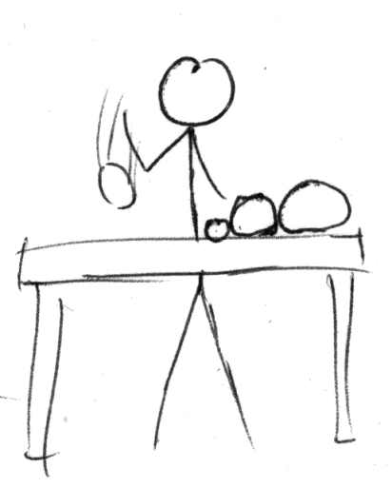
Items needed: a table or other surface, paper and pencils; stones of different sizes, ranging from small to big.
Activity: Show the stones. Let the students listen to the sound of the different-sized stones as you drop them on the table, the floor, a big box, or some other surface.
Let the students describe the different sounds: little “pings” and big bangs.
Then have the students draw all of stones, each one the actual size.
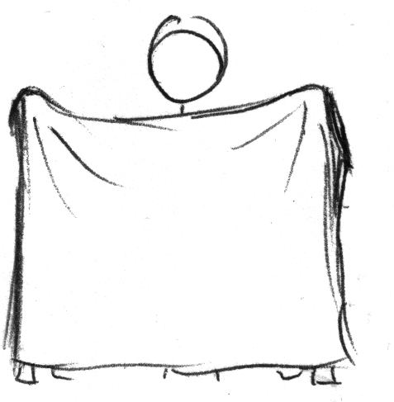
Let the stones drop in a place where the students don’t see them, only hear them. Let the students then draw the size of stone that they think it is. Or have them take turns pointing to a proper-sized stone in one of the drawings.

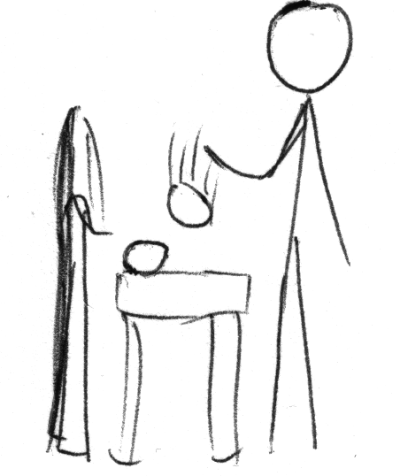

C8 Who do you hear? (Distinguishing Sounds)

Skills practiced: hearing the difference between sounds (necessary in reading), concentration, creativity.
Preparation; Items needed: none
Activity:
- Have the group sit together in the grass, on chairs, on the floor.
- Choose two students to be two animals that make similar sounds. In the Netherlands, this might be a duck (“whaa”) and a frog (“waap waap”). In American English, these might be a sheep (“baa”) and a chicken (“baak, bak, baak”).
- These two stand in front of the group with their backs to the group. When student “A” makes his animal sound, those listening raise their right hand. When student “B” makes her animal sound, those listening raise their left hand.
- After a while let other students take a turn at making other sounds. The fun is in making weird sounds. Make sure you laugh a lot together.
- Point out the differences in the sounds, too, or ask students to describe the differences in the two sounds.
- On a blackboard or big sheet of paper you might write the letter that the different sound represents (maybe the “p” sound in the Dutch example or the “k” sound in the English example).
- Make other sounds: big dog waf, little dog wuf; cat rrrring, lion rrroar; bee bzzzz, cricket biz biz biz, etc.

