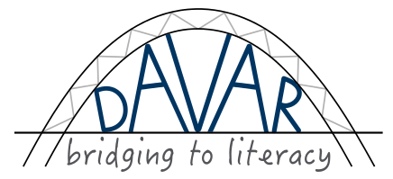
Introduction to DAVAR Curriculum

Goal: Children or adults of any age learn and practice necessary skills that help enable them to learn to read and write.

Purpose: Offer a 'bridge to literacy' by providing a curriculum consisting of activities or games that teach, and offer practice in, necessary skills for learning to read, write, and do math. Attract students to the learning process through these activities and help them discover that academic learning is easier and more fun than they (might have) previously thought or experienced.

Rationale: It is a good and well-known didactic principle to use the known to explain the unknown. When teachers use the languages and ways of learning that students already know in order to teach them new things, students will feel respected, as well as able and motivated to learn. This will create the positive learning environment needed to be able to acquire new skills and learn new concepts.
Even when past the age of preschool and early school years, people can still learn to read and write. Some things should be taught first in order to develop the needed skills; practice is needed to develop the sequential part of the brain necessary to be able to easily learn school subjects.

Target groups:
a. Children or adults who have missed opportunities to master these skills in preparation for learning to read and write (students with no preschool experience) and/or children or adults who have low motivation to learn.
b. Workers with or without pedagogical training who wish to teach these skills.

Description: The program is simple and fun to do. It can be done with few, readily found materials. Since students succeed in participating in the activities, it is also affirming for them.
Each activity takes about fifteen minutes. There is no set order or program to follow; the curriculum consists of activities/games that focus on eight different skill sets. The activities may be used in any order chosen by the leader/teacher and incorporated into existing meetings. They may be part of a Sunday school, Bible club, or other regular meeting. It would be helpful if students meet at least once a week.
Where possible, the language of communication should be the language that students know best.
Learning materials needed: paper, pencils, printed pictures, and easily found objects such as sand, stones, and sticks. Optional materials: worksheets (available for free from internet).

Activities and Games are available in the following skill sets:
A. Verbal Skills
B. Identifying Shapes
C. Listening Skills
D. Visual Skills
E. Feeling and Drawing to develop writing skills
F. Words of orientation in space
G. Describing and Comparing
H. Numbers
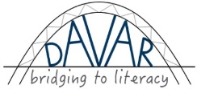
I. Math Games

E-mail: Bridging_to_literacy@yahoo.com.
Created by M. Schönthaler, M. Fast, A. Ivan, and E. Holmes. Copyright 2014.
D Visual Skills
Skills practiced: observe differences (important in discerning differences between letters), describing, remembering order, also right-to-left or left-to-right; take tasks seriously.

#D1 See the Difference
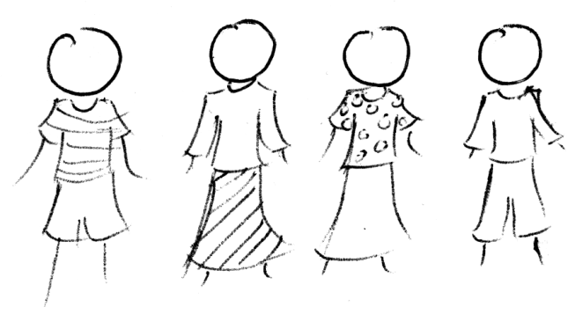
Needed: At least 5 students.
Activity: Three students stand in a row in front of the group. The teacher says something about each of them (for instance: this boy has blond hair, this girl is wearing green pants etc.)

Have everyone close their eyes.
Have the students in the row change places.
- Ask the group: can you see the difference? What order were they in before?

Add more people to the row and repeat.
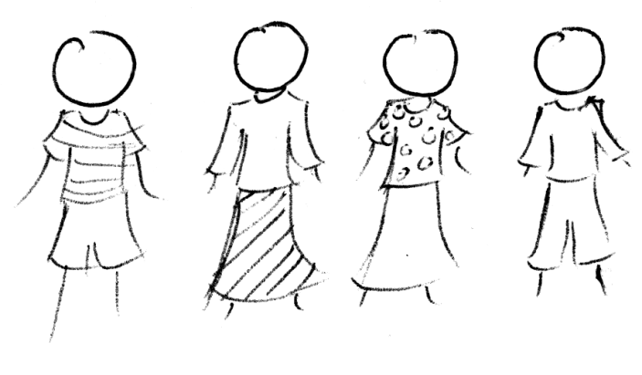
Add even more people and repeat until the students can’t remember the changes anymore or until everyone is part of the row.

Variation: Use several toys or other small objects instead of students.
Repeat a few times, or, if appropriate, give a few students turns to do the changing/adding.

Optional worksheet: #D1 Spot the Differences
Additional free worksheets available from:
http://www.activityexpress.co.uk/spot_the_difference_activities.html

#D1 Visual Skills: See the Difference
Bridging_to_literacy@yahoo.com

C. LISTENING SKILLS

Skills practiced: concentration, discerning differences in sounds (needed in learning to read), taking turns.

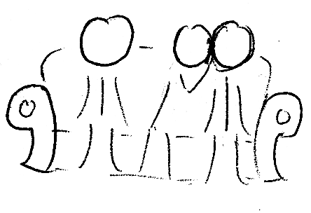
#C1: Telephone

Needed: Nothing

Activity: Everyone sits down in a circle.
Whisper a word in one person’s ear.
They whisper the word in the next person’s ear, all the way around the circle.
When the word comes to the last person, they say it out loud. Is it the same word?

Variations:
Write the first word on a piece of paper or blackboard. Don’t let anyone see it. When the last person says the word out loud, show the class the word you wrote down. Write down the word the last person said. Is it the same?
Increase difficulty by whispering a phrase rather than just one word (for example, “a big dog” or “free french fries”).
Increase difficulty by whispering a whole sentence.

#C1 Listening Skills: Telephone
Bridging_to_literacy@yahoo.com

A. VERBAL SKILLS
Skills practiced: Ordering, use of words, vocabulary building, creativity.

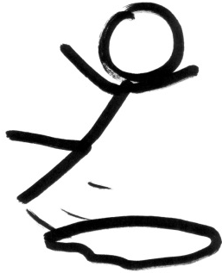
#A1 Finish the story
Needed:
a. Picture from a well-known story or of a situation easily recognized by the students and that can have possible continuing actions (for instance, a person just about to fall into a puddle).

b. A blackboard or large piece of paper to “publish” a story.

Activity: Show the picture to the students and ask them to tell what they see. Then ask them to suggest different endings to the story.
“Publish” the best story (funniest, most descriptive of surroundings, most different words used)
OR “Publish” as many stories as possible.
Save the story/stories for future reading exercises.

Optional Worksheet: #A1 Put the pictures in order.
Additional free story sequencing worksheets:
http://www.greatschools.org/worksheets-activities/5316-story-sequence.gs
http://www.dltk-teach.com/minibooks/apples/sequencing.htm

#A1 Verbal Skills: Finish the Story
Bridging_to_literacy@yahoo.com

G. DESCRIBING AND COMPARING
Skills practiced: vocabulary for positions (left, right, under, over) and properties (heavy/light); sense of touch (necessary for writing); reasoning (preparation for math); staying on task.

#G5 How heavy is it?
Needed: about 15 stones (or other items) of different sizes and weights.
Activity: Let a student hold a stone. Is it heavy or light? Give him another stone much lighter or heavier. Let him/her hold it and then describe the difference. Help with the description by mentioning words like big/small, heavy/ light, heavier/lighter, weight/weighs.
Discuss what makes a stone or an object heavier (size, type of material). Ask for examples of things that are big but light (balloon, feather) or something small but heavy (metal, stone).
Divide the students in groups of four. Give each group four stones of different weights. Let each person in the group hold each of the four stones.
Then have the students stand with their hands behind their backs. Give everyone one stone. Let them move to make a row ranging from heaviest to lightest. Check it and praise the groups that are in the right order.
Repeat this by letting the students exchange stones with each other, then regroup in a row.
Variation: Use objects other than stones such as potatoes, books of different sizes, plastic bottles with different amounts of water in them, plastic bags filled with different amounts of rice . . . .
Optional worksheet: Worksheet #G5a or #G5b How heavy is it?

#G5 Describing and Comparing: How Heavy Is It?
Bridging_to_literacy@yahoo.com

G. DESCRIBING AND COMPARING
Skills practiced: observing and describing differences and properties (important in discerning differences between letters), polite ways of speaking to adults, sorting items according to given criteria.
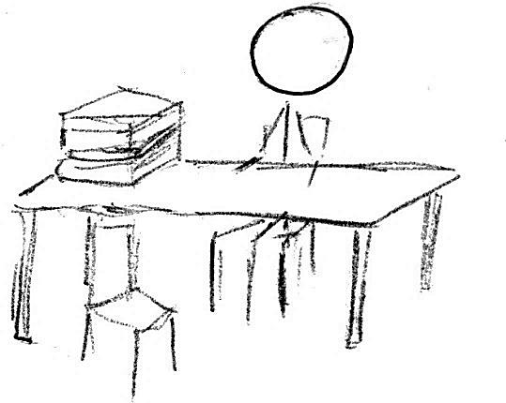
G#7 The Library
Needed: At least 10 books (more if there are more students). The books must differ in size, colour and cover design (pictures or words).
A table and two chairs (one for the librarian and one for the borrower).
Activity: The teacher starts as the librarian, and students take turns coming to the table to borrow books. They have to greet the librarian properly. They have to politely ask for the book they want and use descriptive words in a sentence to describe it. For example, “Good morning/afternoon. May I please borrow the book which is thin and has a white cover?” Or “I would like a book with lots of pictures, please.”
After the librarian gives the requested book, the student has to thank him/her for it and say good-by. The librarian can ask the class to make sure that book is the one the student asked for.
Finally, the students return all the books. They can arrange them according to a clear criterion such as putting all big books behind the chair, all small books under the table, and all the medium-sized books next to the window.
Variations:
Sometimes give the wrong book, which the class should notice.
Have a student be the librarian.
Increasing the number of descriptions needed to request a book. For example, instead of saying, “I would like a small, white book,” say: “I would like a small, thick, square-shaped white book with green letters on it.”
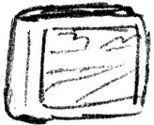
Tip: Speaking politely differs from language to language. Some cultures do not typically greet people when they meet. Some cultures do not use “please;” others do not frequently use “thank you;” others use polite and informal verbs, pronouns, etc. Discover what is typical in the students’ own language as well as the national language.
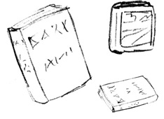

G#7 Describing and Comparing: The Library
Bridging_to_literacy@yahoo.com

DAVAR WORKSHEET #D1--SPOT THE DIFFERENCES

Find and circle 5 differences between the two pictures.

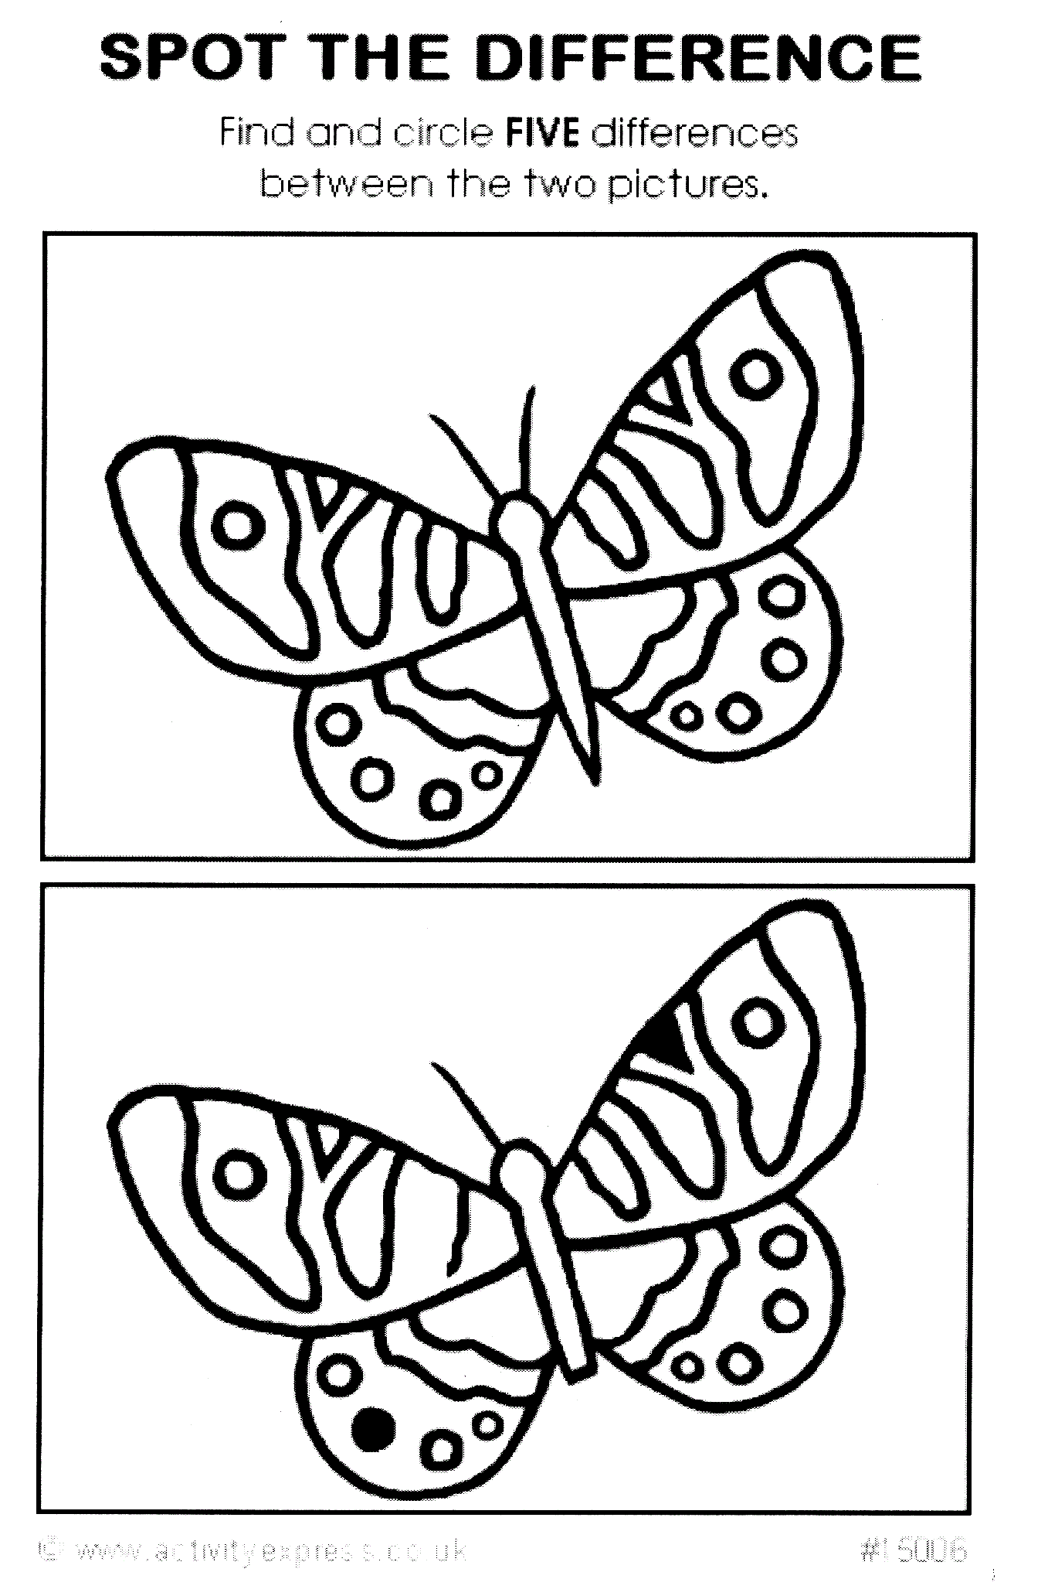
DAVAR WORKSHEET #A1—PUT THE PICTURES IN ORDER

Which picture comes first in this story? Number the pictures from 1-4
OR cut the pictures out and put them together in the proper order.
(Extra: Tell the story you see in the pictures.)
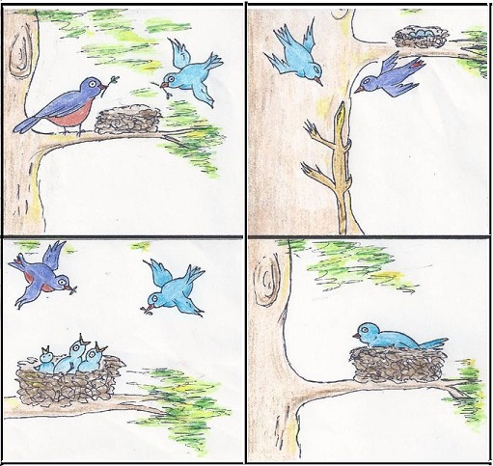

#A1 Verbal Skills: Worksheet Put the Pictures in Order
Bridging_to_literacy@yahoo.com

WORKSHEET #G5a--The Scale
Pick two items. Place them on the scale.
Which is lighter? Which is heavier?
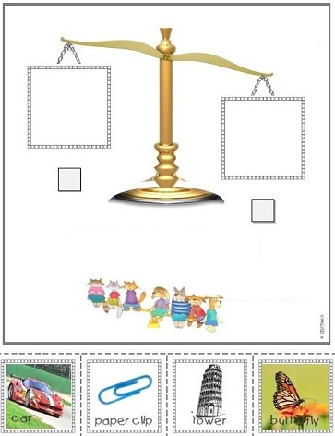
DAVAR WORKSHEET: #G5B HOW HEAVY IS IT?

Which things are heavy? Which things are light? Color the heavy things one color (blue?) and the light things another color (yellow?) OR circle the heavy things and draw a line under the light things. (Tip: ask students to tell the name of these objects in their own language.)

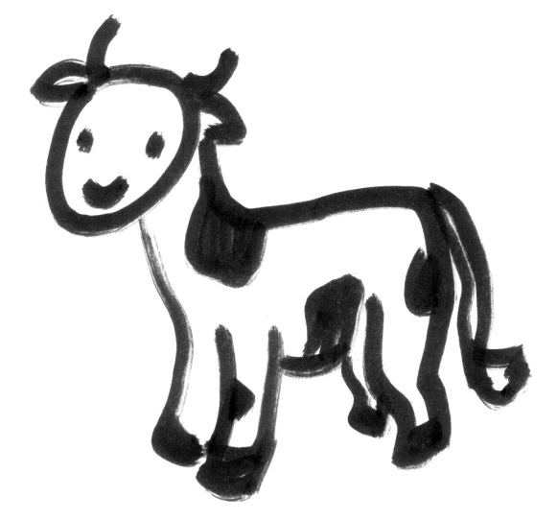

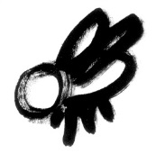

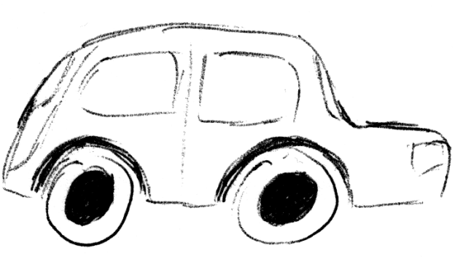
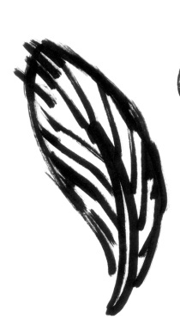

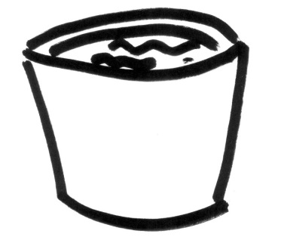

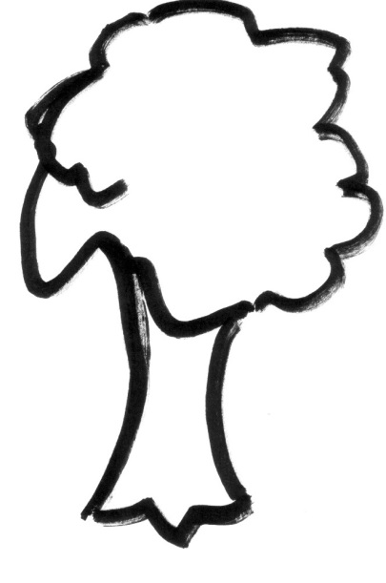

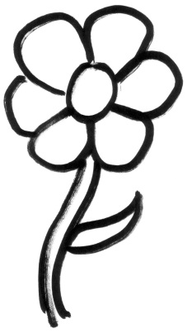
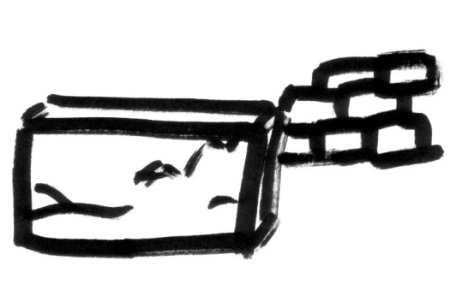

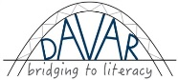
#G5 Describing and Comparing: Worksheet #G5b
Bridging_to_literacy@yahoo.com

